TOWN OF SPRINGDALE – April 2023 Newsletter

Fiber to Every Household

I mentioned in the January 2023 newsletter that one of the initiatives we are working on is getting fiber optic internet to every resident of Springdale. The State of Utah has announced "Connecting Utah," a new statewide initiative to expand high-speed internet throughout the state. The program is intended to make high-speed internet available, accessible, and affordable for every Utahn. Of course, subscribing to the service will be optional, but at least everyone will have the option.

As part of the planning process, Connecting Utah wants to identify the areas with the greatest need for improved internet service. We are fortunate to have two fiber optics providers with lines on SR-9 in Springdale. This means we only need funding for the "last mile," bringing fiber to the residential properties. In other areas of the state, no fiber is available, and it will be a longer, more-expensive process.

Please take the 60-second internet speed test at https://speedtest.utah.gov. The more residents that take the test, the better our chances are of getting funding. Please also encourage your friends and neighbors (and residents of Rockville) to take the test.

There is also funding available to help those who qualify afford high-speed internet by giving a $30 credit toward their monthly internet bill. Information on that program is available at acp.utah.gov.

Thanks in advance for taking the speed test and moving us toward fiber optics for all Springdale residents.

Community Bike Ride: Save the Date!
Did you know that May is bike month? We want you to come celebrate it with us! Hop on your old 10-speed and join us in our annual community bike ride! We’ll be meeting at the Town Park gazebo on SATURDAY, MAY 6 @ 10:00 AM and riding through town! Prizes and refreshments will be available at the finish line. We hope to see you there!
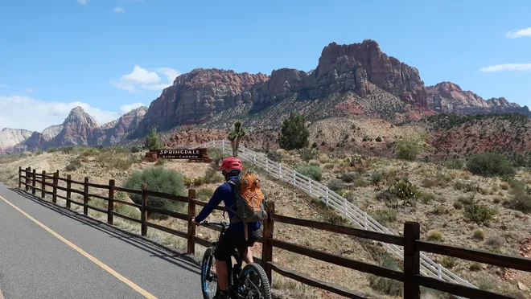
IMAGE: Image of a bike rider riding on the bike path near the entrance to the Town of Springdale.

Air Quality Task Force & PurpleAir Air Quality Monitoring
Some years ago, concerns over air quality, particularly the air quality and health impacts of fugitive dust from construction activities prompted the creation of an air quality task force within Washington County. The Task Force is a partnership between construction companies, the Association of General Contractors (AGC), and local and state agencies. The Town of Springdale is a participating member of the Task Force.

The primary focus of the Task Force is public education and awareness of fugitive dust. Attached to the newsletter is a flyer that the Task Force developed to provide information on dust from construction sites and contract information for concerns. Concerns are relayed back through the Task Force and the AGC to the contractor to make corrections in operations.

The Task Force also promotes the establishment of air quality monitoring sites throughout the County. PurpleAir air quality sensors have been installed throughout the State and Washington County (including in Springdale) and provide real-time data on the air quality. The PurpleAir map and information on data collection can be found at map.purpleair.com. Within the map, a user can select a number of air quality data sets. Fugitive dust impacts the PM10 quality index and is the main concern of the Task Force.

High Water in Zion
We all know the Narrows can be a great place to hike, but, especially at this time of year, it’s important to plan ahead because high water can affect access. In past years when there’s been significant winter and spring precipitation, it has affected water flow in the Virgin River through the Narrows. Check the Narrows webpage on Zion National Park’s website to see a table that shows information about the last decade of closures in winter and early spring, and take a look at the US Geological Survey stream gauge to get up to date information about current flow to share with visitors.

No matter where you’re headed in Zion, know before you go! Check the forecast, dress in layers, drink and carry plenty of water…and have a back-up plan!

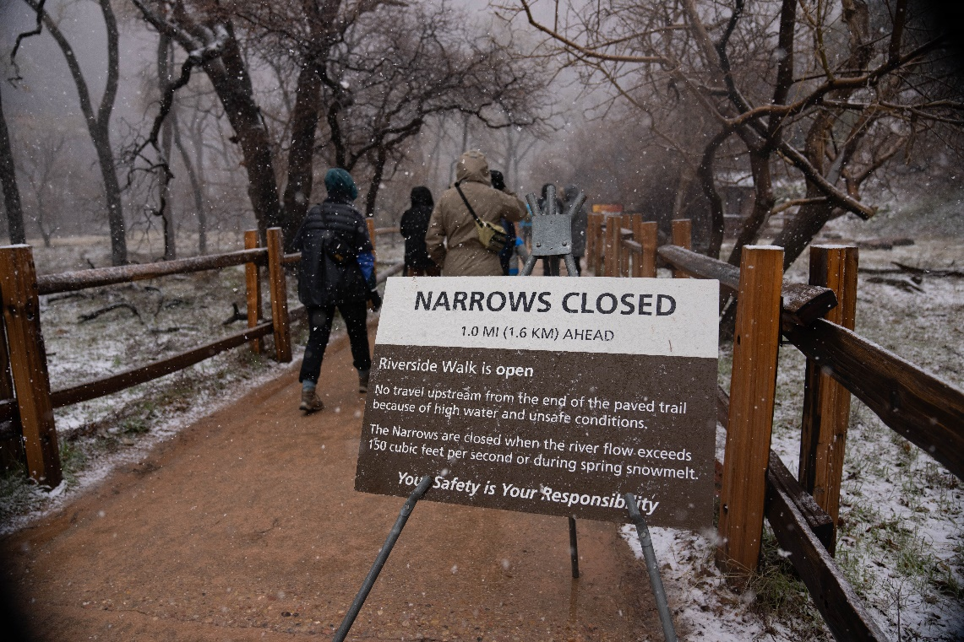
IMAGE: Image of Riverside Walk Trail in ZNP with a sign posted that the Narrows is closed.

Thank you for Celebrating

Thank you to everyone who came out to celebrate the Town’s Birthday this month, it was a smashing success! We hope to be able to have this event annually and keep improving it as we go. I wanted to personally issue a thank you to all of the public bodies and staff members and their family members who attended and set up booths - many hands definitely made quick work!

Also, how great was it to have a juggler? Thank you so much to Jenny Martin for donating her time and talents for our special event. Springdale Jeopardy was a huge hit and a lot of fun; I hope everyone learned something about this unique and fun Town. If you have any comments or ideas for next year’s party, please send an email to sheaton@springdale.utah.gov

Help Improve Broadband in Springdale

You can help shape the future of high-speed internet in Springdale and Rockville. Is your internet service slow, nonexistent or too expensive? There is funding coming to Utah to increase high-speed internet accessibility. Your input is needed to make sure some of that funding is directed to improving online connectivity in Springdale and Rockville Here’s how you can help:

- Take the 60-second Utah Internet Speed test at speedtest.utah.gov. Information gathered from the tests will impact where broadband expansion occurs. The more test results showing poor connection in Springdale, the more likely funding will be directed our way to improve online accessibility. If you don’t have internet, please share your input by calling 435-264-8880.
- Share your story by taking the High-Speed Internet Survey at allonline.utah.gov. The survey and website information are also available in Spanish.
- Encourage your family, friends, neighbors and colleagues to take the speed test and survey. The more you help spread the word, the greater impact it will have on the future of high-speed internet in Springdale.
- The survey and website information are available in English and Spanish.

Connecting Utah, an initiative of the Utah Broadband Center, will use the results of the speed tests and surveys to determine where to direct federal funding designated for improved broadband access. Connecting Utah’s goal is to make high-speed internet available, accessible and affordable for every Utahn.

To learn more about Connecting Utah and other ways you can help, visit allonline.utah.gov. For questions, contact a Connecting Utah representative at 435-264-8880 or connectingutah@utah.gov.

There is also funding available now through the Affordable Connectivity Program to help those who qualify access high-speed internet. This program provides eligible households $30 off their monthly internet bill. Visit acp.utah.gov for more information.

Springdale Library Events – April 2023
1. MINI ART SHOW
It's back! This month's theme is Spring
Entries due April 1st - April 30th 2023. Art will be displayed through the month of May
Pick up your mini-canvases at the Springdale Library between April 1st- April 29th 2023 bring your completed art back by April 30th.
2. ART BOOK CLUB – Saturday, April 22nd 1pm - 2:30pm
Ages 6 to 15
Artist book: Ablaze with Color: A Story of Painter Alma Thomas Visit the library Facebook page for more information and to watch videos of the book being read aloud. Advanced Registration is required. Call (435) 772-3676.
Sponsored by the Canyon Community Center and the Springdale Library
3. PAINT NIGHT – Thursday, April 13th @ 6:30 pm
The event is open to patrons 18 and older. All materials are provided.
Space is limited. Please register in advance @ 435-772-3676 or anna.weyher@washco.utah.gov
4. TWEEN BOOK CLUB – Wednesday, April 26th @ 4:00 p.m.
Book Discussion: When You Trap a Tiger by Tae Keller
Registration Required 435-772-3676 or alexis.degraw@washco.lib.ut.us

Other Flyers

1. Zion Chalk & Earth Fest
Live Entertainment, food, beer garden, educational vendors, and chalk art! Saturday, April 29th through Sunday, April 30th. 10:00 am to 6:00 pm at the Zion Canyon Village, 147 Zion Canyon Boulevard, Springdale.

2. Vaccination Clinic Saturday, April 15, 2023
9:00 AM until 12:00 PM
Sponsored by the Springdale Police Department and Zion Animal Lovers

Location: Springdale CCC Back Patio at 126 Lion Blvd., Springdale
Please do not bring your animals through the Community Center
Veterinary Clinic: Dr. Casey Wittwer, Zion Veterinary Hospital
Vaccines and Services Available (cash or credit card only for vet service):

DOGS:
Rabies 1 year and 3 years $18.87
DA2PP (distemper, adenovirus-2, parainfluenza, parvovirus vaccine) $22.20
Bordetella (kennel cough) $24.42
Lepto $24.42
Rattlesnake Vaccine $24.42

CATS:
Rabies 1 year and 3 years $18.87
FVRCP (feline viral rhinotracheitis, calicivirus, panleukopenia vaccine) $22.20
FeLV (feline leukemia vaccine) $22.20 INFLUENZA $47.73
MICROCHIP AND REGISTRATION $38.85

ADDITIONAL SERVICE PROVIDED BY SPRINGDALE / ROCKVILLE TOWNS:
Springdale Dog Licensing (due May 1, 2023): $5 for spayed/neutered dogs; $40 for unaltered dogs. Rockville Dog Licensing (due December 31, 2022): $5 for spayed/neutered dogs; $15 for unaltered dogs.

This is a great opportunity to get your animals vaccinated with resources coming close to your home, and you will save the cost of an office visit. If you have any questions, please contact Jen at the Springdale Police Department at 435-772-9096, or Robin Smith at Zion Animal Lovers 435-817-1124.

PROTOCOLS FOR THE VACCINATION CLINIC
•Animals must be leashed at all times.
•There will be an option to wait in your vehicle after check in with the staff. With this option, the Veterinary staff will come to your vehicle to vaccinate the animal.
•Springdale/Rockville dog licensing/registration will be available.

3. Semi-Annual Household Hazardous Waste Day
Saturday, April 15th From 8 AM to 12:30 PM
Located at 325 North Landfill Road, Washington Utah Don't miss out! Your next opportunity won't be till October 14th!

What to Bring?
Adhesives (Glue, Caulking, etc)
Aerosols (Hair Spray, Bug Spray, etc)
Automotive (Batteries, Antifreeze, Oil, etc)
Batteries (Cell, Dry-Cell, Ni-Cad, Lithium, Alkaline, Lead-Acid)
Cleaners (Kitchen, Bathroom, etc)
Fuels (Gasoline, Diesel, Kerosene, lamp oil, oil/gas mixtures etc)
Oxidizers (Chlorine, Bleach, Fertilizer etc)
Poisons (Lawn herbicides, Rodent poison, Weedkillers, etc)
Propane Cylinders (BBQ or Camping Propane tanks, etc)
Solvents (Paint thinner, Acetone, Alcohol, Benzene etc)
This is a FREE event for Washington County Residents wanting to dispose of HHW from their primary homes.

4. FUGITIVE DUST CONTROL Self-Inspection Handbook
How to Control Dust and Reduce Air Pollution
What is fugitive dust?
Dust Pollution Problems Clean Operating Tips

TOP TEN DUST CONTROL MEASURES
1. Create and follow a Dust Control Plan.
2. Pre-water area prior to excavation activities.
3. Install and maintain Track-Out Pads on jobsites.
4. Establish designated parking for jobsite personnel.
5. Limit access points for construction sit e.
6. Cover truck material loads on public highways.
7. Reduce speeds on haul roads. (Max. Speed 10 mph.)
8. Maintain water systems on crusher plant operations.
9. Create crusting of topsoil on non-working projects.
10. Stop operations on high wind days (30 mph+).

Together we need to focus on preserving our good air quality. We can only achieve this through a conservative effort by all.

The public and employees of industry are becoming more aware of the health hazards of dust. Particulate matter (PMIO) particles have been linked to increased health effects.

Activities of aggregate operations, development projects that clear land, material transport activities on unpaved roads, and other factors add to the ever-increasing problems associated with fugitive dust.

Springdale Meetings Calendar – April 2023
Visit the Community Calendar at www.springdaletown.com for the most up to date event schedules.

5. April Meetings Calendar
Saturday, April 1, 2023 - Alcoholics Anonymous: 7:00PM-8:00PM
Monday, April 3, 2023 – Al-Anon: 5:00PM-6:00PM, Alcoholics Anonymous: 6:30PM-7:30PM
Wednesday, April 5, 2023 – Zion Canyon Visitor’s Bureau: 2:00PM, Planning Commission Work Meeting: 5:00PM-7:00PM
Saturday, April 8, 2023 – Alcoholics Anonymous: 7:00PM-8:00PM
Monday, April 10, 2023 – Al-Anon: 5:00PM-6:00PM, Alcoholics Anonymous: 6:30PM-7:30PM
Wednesday, April 12, 2023 – Town Council Regular Meeting: 5:00PM-7:00PM
Saturday, April 15, 2023 - Alcoholics Anonymous: 7:00PM-8:00PM
Monday, April 17, 2023 - Al-Anon: 5:00PM-6:00PM, Alcoholics Anonymous: 6:30PM-7:30PM
Wednesday, April 19, 2023 – Planning Commission Regular Meeting: 5:00PM-7:00PM
Saturday, April 22, 2023 - Alcoholics Anonymous: 7:00PM-8:00PM
Monday, April 24, 2023 - Al-Anon: 5:00PM-6:00PM, Alcoholics Anonymous: 6:30PM-7:30PM
Thursday, April 27, 2023 – Town Council Budget Work Meeting: 10:00AM-12:00PM
Saturday, April 29, 2023 - Alcoholics Anonymous: 7:00PM-8:00PM
Sunday, April 30, 2023 – Earth Day!
Monday, May 1, 2023 - Al-Anon: 5:00PM-6:00PM, Alcoholics Anonymous: 6:30PM-7:30PM
Wednesday, May 3, 2023 – Zion Canyon Visitor’s Bureau: 2:00PM, Planning Commission Work Meeting: 5:00PM-7:00PM
Saturday, May 6, 2023 - Alcoholics Anonymous: 7:00PM-8:00PM

6. April CCC Class Schedule
Sunday, April 2nd:
Free Fitness Meetup @ Gazebo 12PM-1PM
Crystal Sound Bath Meditation 11AM-12PM

Monday, April 3rd:
Free Bingo 10AM-11AM
Free Community Games 11AM-1PM

Tuesday, April 4th:
High Fitness 9:15AM-10:15AM
Vinyasa Yoga 5:30PM-6:30PM

Friday, April 7th:
Gentle Yoga 10AM-11:15AM
Free Fitness Meetup @ Gazebo 12PM-1PM
#1 Art Workshop- Deep Dive Into Color 3PM-5:30PM

Saturday, April 8th:
#2 Art Workshop- Deep Dive Into Color 3PM-5:30PM

Sunday, April 9th:
Free Fitness Meetup @ Gazebo

Monday, April 10th:
Free Bingo 10AM-11AM
Free Community Games 11AM-1PM

Tuesday, April 11th:
High Fitness 9:15AM-10:15AM

Friday, April 14th:
Gentle Yoga 10AM-11:15AM
Free Fitness Meetup @ Gazebo 12PM-1PM
#1 Art Workshop- Deep Dive Into Color 3PM-5:30PM

Saturday, April 15th:
Animal Vaccination Clinic 9AM-12PM
#2 Art Workshop- Deep Dive Into Color 3PM-5:30PM

Sunday, April 16th:
Free Fitness Meetup @ Gazebo 12PM-1PM
Crystal Sound Bath Meditation 11AM-12PM

Monday, April 17th:
Free Bingo 10AM-11AM
Free Community Games 11AM-1PM

Tuesday, April 18th:
High Fitness 9:15AM-10:15AM

Friday, April 21st:
Free Fitness Meetup @ Gazebo 12PM-1PM
#1 Art Workshop- Deep Dive Into Color 3PM-5:30PM

Saturday, April 22nd:
Kids Book Art Club- Ablaze with Color: A Story of Painter Alma Thomas 1PM
#2 Art Workshop- Deep Dive Into Color 3PM-5:30PM

Sunday, April 23rd:
Free Fitness Meetup @ Gazebo 12PM-1PM

Monday, April 24th:
Free Bingo 10AM-11AM
Free Community Games 11AM-1PM

Tuesday, April 25th:
High Fitness 9:15AM-10:15AM
Macrame Workshop 5:30PM-8:30PM

Wednesday, April 26th:
Free Chalk Art Workshop 6:30PM-8PM

Friday, April 28th:
Free Fitness Meetup @ Gazebo 12PM-1PM
Art Workshop- Artist Talk & Open Studio with Carol Bold 3PM-5:30PM

Saturday, April 29th:
Zion Chalk & Earth Fest. 10AM-6PM @ the Zion Canyon Village

Sunday, April 30th:
Zion Chalk & Earth Fest. 10AM-6PM @ the Zion Canyon Village
Crystal Sound Bath Meditation 11AM-12PM
Free Fitness Meetup @ Gazebo 12PM-1PM

